Lab: HTML and CSS Basics
Problems for in-class lab for the "Programming Fundamentals" course @ SoftUni.

Welcome to HTML
Create a web page like the following:
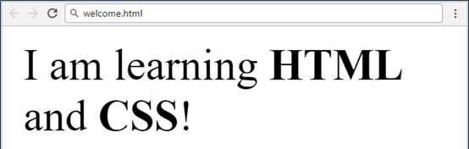

Constraints
- Change the file name to welcome.html.
- Use paragraph tag for plain text and strong tag for bold text.
- Set the title to Welcome.

Fruits
Create a web page like the following:
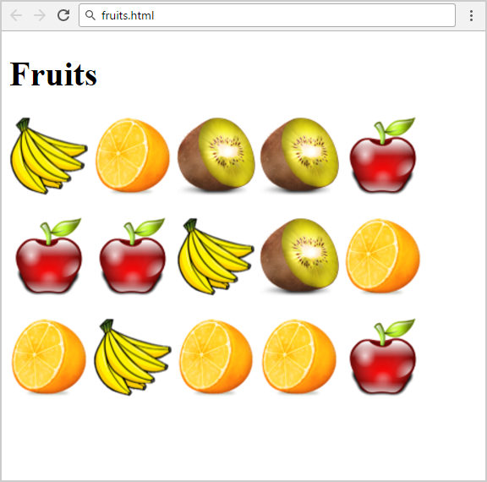

Constraints
- Change the file name to fruits.html.
- You are given 4 image files: apple.png, banana.png, kiwi.png, orange.png.
- Use 3 paragraphs - each holding 5 images.
- Add header Fruits.
- Keep in mind that you need to change the size of the image files to be alike the example above. You can use the <style> tag.

HTML Lists
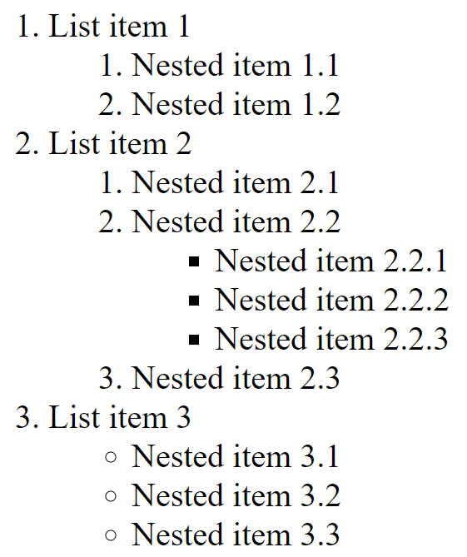

Constraints
- A nested list like the example

Solution
<ol>
<li>List item 1
<ol>
<li>Nested item 1.1</li>
<li>Nested item 1.2</li>
</ol>
<li>List item 2
<ol>
<li>Nested item 2.1</li>
<li>Nested item 2.2
<ul>
<li>Nested item 2.2.1</li>
<!-- TODO: put the next items here-->
</ul>
</li>
<li>Nested item 2.3</li>
</ol>
</li>
<li>List item 3
<ul>
<li>Nested item 3.1</li>
<!-- TODO: put the next items here -->
</ul>
</li>
</ol>

<li>
List item 3
<ul>
<li>Nested item 3.1</li>
<!-- TODO: put the next items here -->
</ul>
</li>

Wiki Page
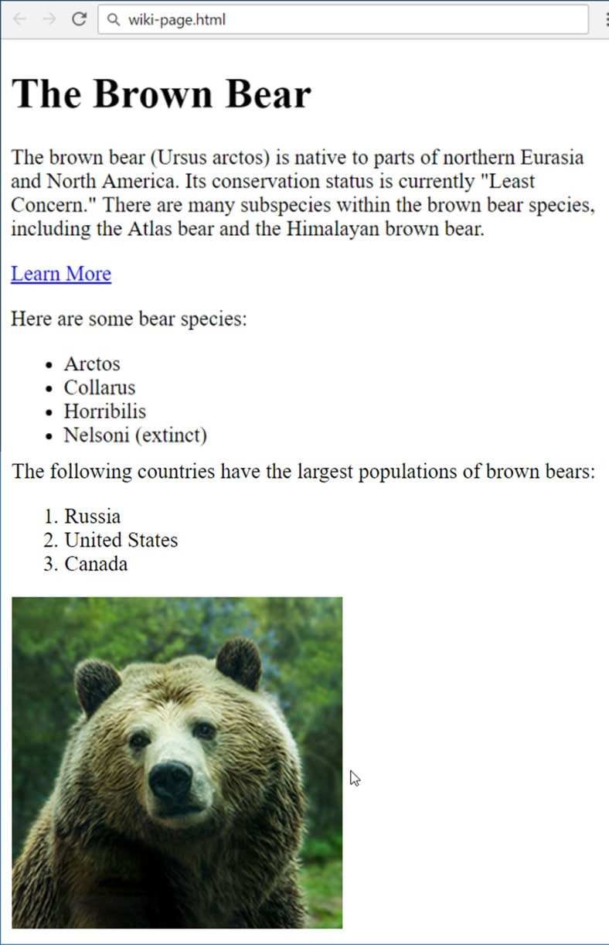
Create a web page like the following:

Constraints
- File name: wiki-page.html.
- Title: The Brown Bear:
  - Use <h1>
- Hyperlink: https://en.wikipedia.org/wiki/Brown_bear.
- List: use ordered list and unordered list.
- Text: use paragraph:
  - Image: use the file bear.jpg

Color Blocks
Use the following HTML:

<div class="green">green block</div>
<div class="blue">blue block</div>
<div class="red">red block</div>
<div class="purple">purple block</div>
<div class="orange">orange block</div>

Аnd style it as the screenshot:
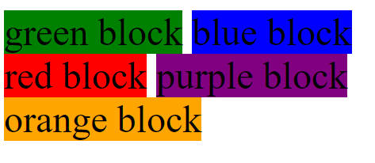

Solution
div {display: inline-block;}
.green {background-color: green;}
.blue {background-color: blue;}
<!-- Implement rest of the styles -->

